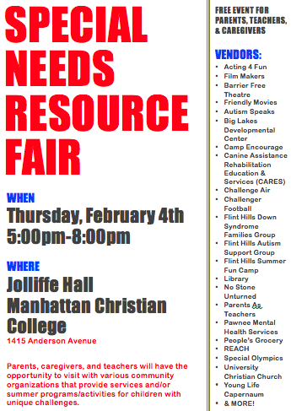
https://www.facebook.com/events/814328875379235/

